<Date>

<Policy Owner Name>
<Address Line 1>
<Address Line 2>
<City> <State> <Postcode>

Customer Number: <Customer Number>
Policy Owner Name: <Policy Owner Name>

Dear <Policy Owner Name>,

Your policy renewal communications are going green
We’re always looking for ways to improve and continue helping you lead a healthier, longer, better life.
Part of this commitment is reducing our impact on the environment. One of the ways we’re doing this is by printing less paper and communicating with you more via email.
Usually, you’d receive your policy renewal information in the mail. Moving forward, we’ll be sending your renewal notice to you via email for all AIA Priority Protection policies that you own. This will begin from your next policy anniversary date.
In other good news, you’ll also receive more communications from us via email and less by post over the coming months. This is all part of our long-term goal of achieving net-zero emissions by 2050.
Your next steps
<IF CUSTOMER HAS EMAIL ON FILE>
If you’ve provided us with your current email address, you don’t need to do anything. You’ll automatically receive your renewal notice, and future policy communications via email on the same schedule as previously. The email address we currently have on file is: <current email address>.
If you’d like to update your email address or if you prefer to receive your policy communications via post, please contact our Customer Care team on 1800 333 613 or via email at infohub@aia.com.
<IF CUSTOMER DOES NOT HAVE EMAIL ADDRESS ON FILE>
We currently don’t have your email address on file. If you’d like to receive your policy communications via email, please scan the QR code below to update your email address or you can complete the Change of Email Address Form attached and send it to <infohub@aia.com>. Alternatively, you can contact our Customer Care Team on 1800 333 613 or email us at infohub@aia.com.
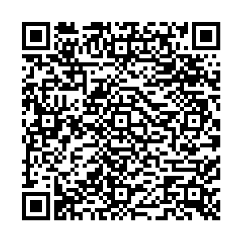
If you prefer to continue receiving your communications via post, you don’t need to do anything.
We’re here to help
If you have any further questions, please call us on 1800 333 613 between 8am to 6pm (AEST/AEDT), Monday to Friday, excluding public holidays.
Kind regards,
AIA Australia

